
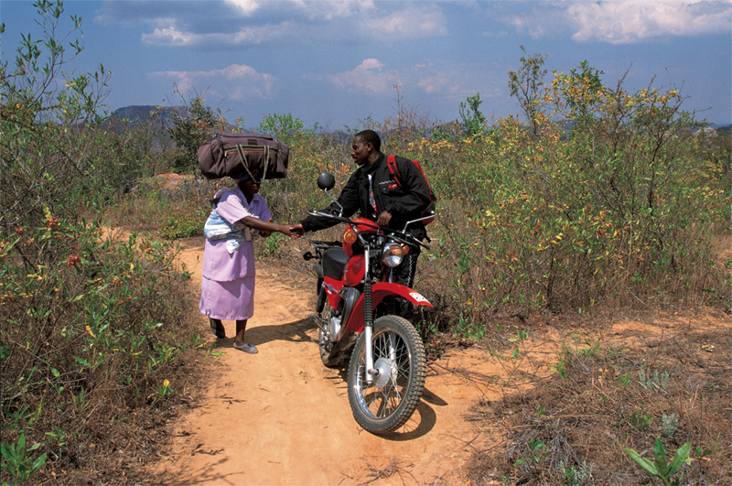

Patron HRH The Princess Royal

RIDERS FOR HEALTH
3 NEW STREET, DAVENTRY
NORTHAMPTONSHIRE N11 4BT
TEL +44 (0) 1327 300047
FAX +44 (0) 1327 308760
E-MAIL rfh@riders.org
WEBSITE www.riders.org

Riders for Health update report

1 October 2004 – 31 March 2005

Zimbabwe

Community

Impressed by the impact of our work, motorcycle manufacturer Honda generously increased their support by donating a total of 75 XL125 motorcycles to enable the delivery of vital health care to rural communities across Africa. To date, 50 vehicles have been handed over to the Ministry of Health and Child Welfare in Zimbabwe for allocation to trained health workers.

Having facilitated the handover, Riders support started with training in safe riding skills, road safety techniques and essential daily preventive maintenance procedures at the International Academy of Vehicle Management in Harare. Fully equipped with protective clothing, the mobilised Environmental Health Technicians have been able to journey further afield, reaching people in remote communities who would otherwise remain inaccessible. The following impact is already being recorded:

- Radius of area covered increased from 20km to 100km

- Three-fold increase in the number of wards covered

- Time spent in the community increased from an average of 3.5 hours to 8.5 hours

- Number of people receiving care increased by over 80%

- Number of births attended increased

- Infant mortality rate decreased

Health workers are reporting that, as they are able to spend more time in each community, people are benefiting from additional heath education, HIV/AIDS counselling, and home-based care. The EHTs are able to react more quickly to outbreaks of disease, including malaria, TB, diarrhoea, cholera, typhoid and anthrax. As they are able to reach affected communities more speedily, they are able to bring the outbreaks quickly under control, preventing the disease from spreading.

One report has been received from Gutu District, Masvingo Province, where a man had eaten meat contaminated by anthrax. Before Riders’ support, it would have taken three days to reach the community. Instead, the nurse was able to reach him and collect a specimen, take it to the laboratory for testing, collect the appropriate drugs and return to the homestead and treat the patient – all in the same day. Action was also taken to prevent the disease from spreading by covering the ground where the animal carcass had been buried with chloride of lime.

The IAVM

During the six-month period 1 October 2004 to 31 March 2005, 96 delegates were trained at the academy. In addition to those involved with health care delivery, delegates have included agricultural extension officers, micro credit specialists and specialists setting up community-based initiatives to support elderly people. 5 community facilitators were sent for training by Oxfam GB, whilst bursaries were provided for local NGOs with fewer resources. In addition, delegates attended from NGOs based in Zambia and Kenya.

The following report was sent to us by Philip Githui, General Services Coordinator and Biomed Technician for CURE International following completion of the fleet management course, which incorporated “training for trainers”. Philip works out of the Bethany Hospital for Crippled Children in Kenya

In Africa, people usually die of diseases which can be easily prevented and cured. This is mostly due to lack of reliable transport and medical services.
At Riders for Health, they teach, therefore, how to run and maintain a fleet or a vehicle in such a way as to achieve “Zero Breakdown” status. I’ve spent the last one month from 1st to 30th November at their training facility in Harare, Zimbabwe.
This facility is a motorsport complex which is very well equipped for training in riding and driving on tar, mud and through sand .The trainers are very conversant with their work and very patient with the trainees. I went through training on safe defensive driving and riding techniques, putting into consideration other road users and the importance of observing all the rules of the road. The four by four driving was very exciting.
What really impressed me on the “Zero Breakdown” is the way the Riders Workshop service vehicles on schedule and change all the parts as per lifespan which increases the life of each vehicle. The introduction of micro filters for fuel and oil systems is a breakthrough in vehicle maintenance. This opportunity to work with them was a great blessing to me.
It is my great desire to put systems in place to run our small mixed fleet in such a way to ensure that it runs smoothly and without failure. I’d like to thank Riders for the opportunity to learn from them.

The following is an update on developments that have been taking place in the UK-based resource centre:

Attracting global attention : 2004 saw Andrea and Barry Coleman’s tireless 15-year campaign to raise awareness of Riders’ pioneering work start to bring in results. Both co-founders of Riders for Health gained recognition as two of the world’s outstanding social entrepreneurs when they were invited by the Schwab Foundation, sister organisation to the World Economic Forum, to join their elite network.

The foundation is the leading promoter of social entrepreneurism as a practical, rational methodology for engendering sustainable development in the world’s poverty-affected regions. Andrea and Barry were given the opportunity to present the results of Riders’ work to representatives of more than 90 organisations at the World Summit in Brazil and to attend the World Economic Forum at Davos in January 2005.

Inclusion in the Schwab network means that transportation has been recognised as a key element in the fight against poverty and ill-health. Pamela Hartigan, director, said: Social entrepreneurs use business and innovative revenue models to stimulate social inclusion: they are practical, results-orientated innovators who instigate processes whereby the poor become agents of change and self-determination. Andrea and Barry Coleman have not only found an imaginative solution to a highly complex problem but Riders for Health has enormous capacity to grow throughout Africa, making a lasting and sustainable impact on development.

Raising awareness at the House of Commons : We were given the rare opportunity to hold an exhibition explaining our work at the House of Commons during November. Our presence resulted in reference being made to our system of managed transportation during a debate on international development. Although not the only occasion that a motorcycle had been seen in the Upper Waiting Area, it was the first time one had been exhibited without leaking oil. Yet further evidence of Riders’ effective maintenance disciplines!

Competing in the world of business : Riders for Health was the only charity to win a top business award in the Sage Business Awards 2004, held in partnership with the Daily Telegraph. Andrea Coleman was chosen out of a record number of entries as one of the country’s best business leaders. The Daily Telegraph review of the awards ceremony heralded Andrea and Riders for Health as the Driving force for African health care.

Recognition of best practices : In March, we learned that the Global Health Council had selected Riders to receive the 2005 Best Practices in Global Health Award. This award is given to celebrate and highlight the efforts of individuals in the field dedicated to improving the health of disadvantaged and disenfranchised populations, and to recognise programmes that effectively demonstrate the link between health, poverty and development. Recipients of the award are selected for their ability to exhibit measurable results in the field, as well as the ability and expertise to share, inspire and extend best practices for improving health.

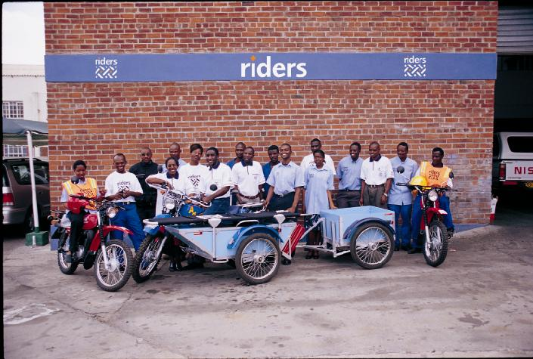
None of these achievements would have been possible without our supporters. Our team in Zimbabwe, shown pictured here with Riders community emergency vehicle, the Uhuru, and all of us at Riders would like to take this opportunity to say

Thank you.

